***NAME: WALEED AKRAM***

***ROLL NO: 20P-0640***

***SECTION: 2B***

**COAL_REPORT_1**

# What is Assembly Language?

A low level computing construct is a sort of low-level programming language that is planned to discuss straightforwardly with a PC's equipment. Not at all like machine language, which comprises of parallel and hexadecimal characters, low level computing constructs are intended to be discernible by people.

# Advantages of Assembly Language

Having an understanding of assembly language makes one aware of −

How programs interface with OS, processor, and BIOS.

How data is represented in memory and other external devices.

How the processor accesses and executes instruction.

How instructions access and process data.

How a program accesses external devices.

# There are many good assembler programs, some of them are −

Microsoft Assembler (MASM)

Borland Turbo Assembler (TASM)

**In today lab we will install and run MASM on windows :**

# Download Link:

<https://www.codingcrew.de/masm32/index.php>

**My first program in assembly language on MASM**

# First Program on MASM:

.386

.model flat, stdcall

option casemap:none

include \masm32\include\windows.inc

include \masm32\include\kernel32.inc

includelib \masm32\lib\kernel32.lib

include \masm32\include\user32.inc

includelib \masm32\lib\user32.lib

.data

msg db "Hello world!!!", 0

cpt db "MY FIRST PROGRAM!!!", 0

.code

start:

invoke MessageBox, NULL, addr msg, addr cpt, MB_OK

invoke ExitProcess, NULL

end start

**MASM ASSEMBLER:**

Creating a new project/code

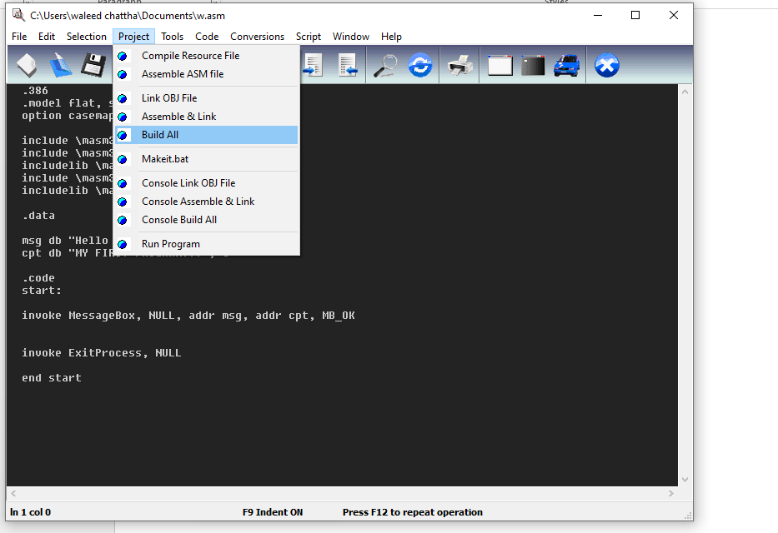

**Program on MASM**

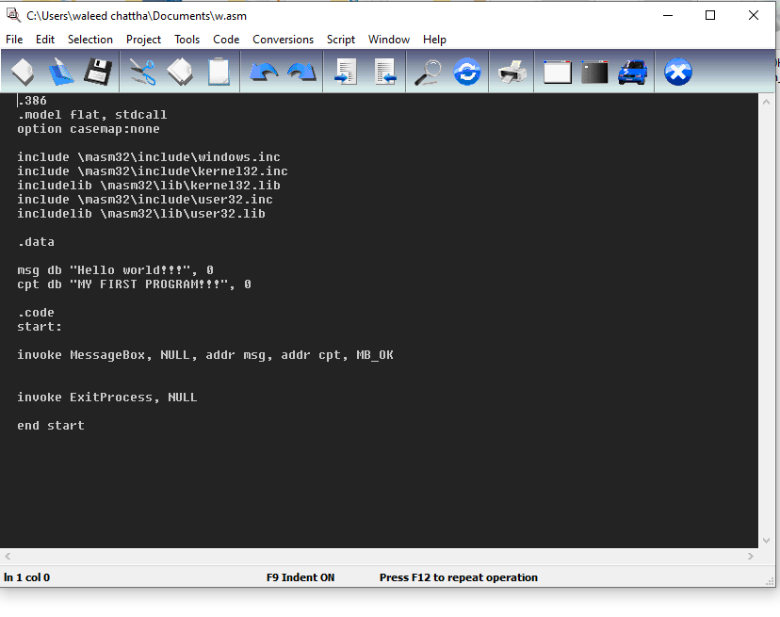

**Assembling code**

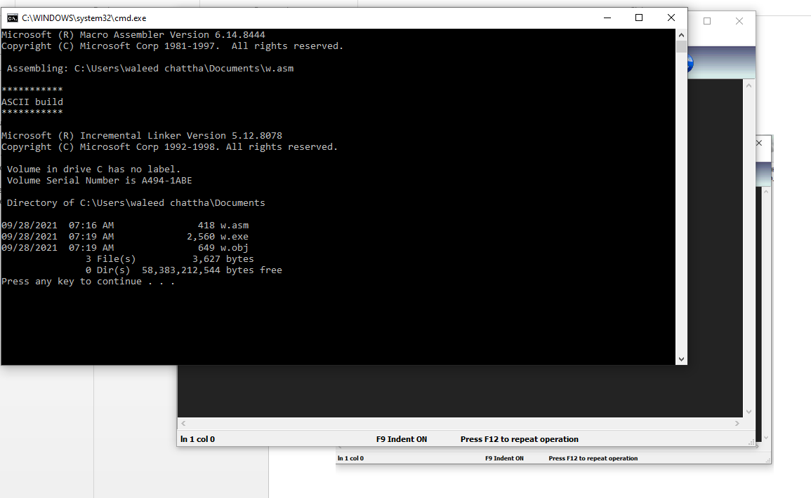

**HERE IS OUTPUT**

